FOOD PANTRY
FEBRUARY - MARCH 2021

Please note that the food pantry will be closed for Holy Week from March 30 to April 2 and April 6.

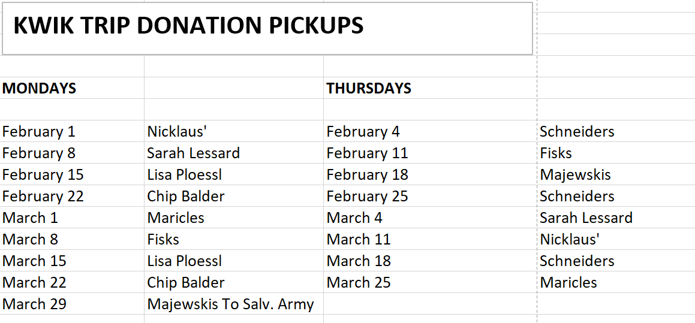

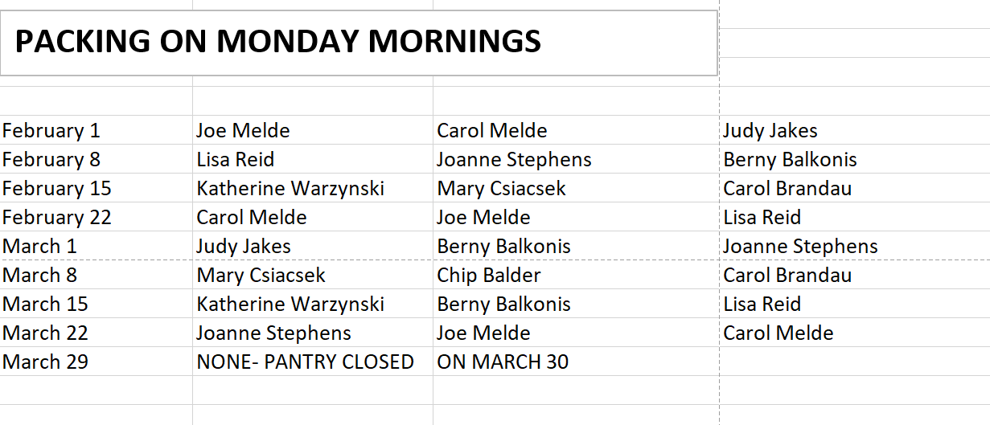
PACKERS – PLEASE REMEMBER TO EMPTY THE SHOPPING CART AT THE CHURCH. LEAVE ANY HYGIENE/CLEANING THINGS IN THE PANTRY AT THE CHURCH, AND TAKE THE DONATED FOOD ITEMS TO THE RECTORY. THIS NEEDS TO BE DONE EVERY MONDAY AND THURSDAY, EVEN WHEN THE FOOD PANTRY IS CLOSED.
